27th Annual Rural West Internship Program
For Diversity in Nonprofit Housing And Community Development

2024-25 Internship Application

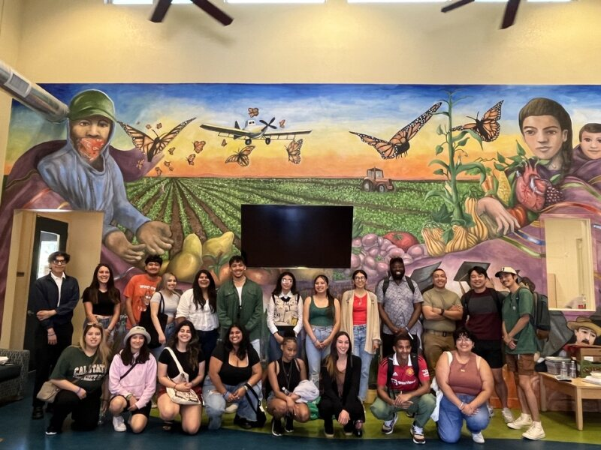

Final Deadline to Apply: May 10th, 2024

program description and application form

(Please read carefully before applying)

The California Coalition for Rural Housing (CCRH) is proud to announce its 27th Annual Rural West Internship Program for Diversity in Nonprofit Housing and Community Development (Internship Program). The Program operates in California, Hawaii, Oregon, and Washington State.

About the Program’s Objectives
The CCRH Internship Program is a one-year paid Internship designed to recruit, train, and retain housing development professionals who enhance inclusion and racial equity within the Affordable Housing Development field. CCRH member nonprofit organizations have responded to the need for affordable housing by building, maintaining, and rehabilitating affordable housing complexes in the rural West since the 1960s. This internship is intended to provide an entry into the affordable housing and community development field to historically underrepresented college students from low-income, rural, and ethnically diverse communities representative of the growing diverse populations served by these nonprofit housing developers. We strongly encourage applications from recent college graduates or students entering their last year of college so that upon graduating from college, they may be able to be employed in entry-level professional positions in the field. Students from all majors are encouraged to apply.

How the Internship Works
There are three main entities that make up the program: The Intern, CCRH, and the Host Agency. CCRH is a nonprofit organization that serves as the Program Administrator and coordinator of the program. We are not a public/government agency. CCRH sponsors the program and coordinates all trainings and supplemental program activities. The Host Agency is the location where each Intern carries out their day-to-day work. Each year, an average of twelve interns participate working and learning at a nonprofit affordable housing developer or housing authority. Interns are selected via a competitive application process from across each state, and placed with a host agency for one year, beginning work in the summer (full-time) and continuing through the spring (part-time). The intern works closely with a supervisor and follows an Intern Work Plan that provides a well-rounded intern experience in the field of nonprofit affordable housing and community development. Host agencies sign agreements with CCRH, and Interns sign agreements with their respective host agency to ensure an understanding of the program terms and policies, and to ensure an optimal experience for the Intern and the Host Agency. Selected interns are placed at host agencies located within driving distance of the university they attend.

During the year, the intern will be actively involved in affordable housing development. The intern will learn hands on what it takes to create affordable healthy living communities, and specifically learn the intricacies of developing and rehabilitating multifamily housing complexes from concept inception to construction completion for low-income and ethnically diverse communities.

On the job learning: Host Agencies will provide opportunities to gain hands-on experience in areas such as these:

- Participating and helping facilitate community meetings about proposed housing developments;
- Assisting with land and property acquisitions;
- Conducting assessments or needs surveys to determine the housing and community development needs of low-income people;
- Participating in planning meetings with the architect and property management on the design of architectural drawings for affordable housing developments and community facilities such as child-care centers and community recreation buildings;
- Assisting with the financial applications and loan closings for housing developments.
- Participating in construction meetings and preparing construction draw requests.

In addition, interns will be exposed to different leadership styles via CEO and Executive Director shadowing experiences; and can further develop their leadership skills through the program’s supplemental activities described below.

program Activities and Other Opportunities
The Intern’s Program year will include a variety of professional and personal skills development opportunities. Interns also get to build community with their peer group and program alumni through various activities and develop strong long-lasting relationships because of the work and activities that occur over the year. These activities will be conducted in a combination of online and in-person sessions. Some of these opportunities include:

Summer Training Institute. Interns begin the program working at their host agencies and then shortly thereafter start attending 2-hour sessions of online training up to two times a week. All interns are expected to attend a four-day in-person training at UC Davis during the last week of July. The rest of the intensive summer training takes place online until the end of August 2-hour sessions three times a week. The Institute is an intensive training where professionals from the industry teach various affordable housing and community development topics. The Institute also provides personal development tools, such as communication and negotiation techniques that Interns can use in their professional and personal lives. The Institute activities help Interns to get to know each other on a personal level and forge bonding relationships with one another so that they feel comfortable communicating and confiding via email/social media/phone once they return home.

CCRH Rural Summit and Statewide Housing Conferences: California Interns can attend and participate in CCRH’s renowned Annual Rural Housing Summit, while Hawaii, Washington state, and Oregon Interns are encouraged to attend their respective statewide Annual Housing Conference. These events usually occur between September and November. Interns will prepare and deliver a brief collective intern presentation at the Rural Housing Summit as part of a plenary.

The Mid-Winter Training: In January Interns take a weekend to participate in a skills development/retreat where they reflect on their intern experience and gain additional soft skills and housing & community development tools.

Enrichment Opportunities: Interns are regularly informed of community development events and news via an Intern email communication initiated by CCRH’s Program Staff and may be invited to attend one statewide or regional housing conference, depending on opportunities. Some Host Agencies sponsor their respective Intern to other non-CCRH trainings, such as the Neighbor Works America National Training Institute, National Rural Housing Conference, etc., (depending on the Host Agency and CCRH partners). Interns are encouraged to apply for conference registration scholarships, when available to attend these convenings.

Final Project. Interns culminate the program with the presentation of a housing development project they have worked on during the year where they must convince a mock city council that their development project is feasible and an asset to the community.

Graduation: Successful Intern graduates participate in a special graduation ceremony typically hosted in May. The graduation is attended by Intern families, CCRH intern alumni, nonprofit leaders, and practitioners from across each state.

Resources and Employment Opportunities after Graduation: CCRH staff support initial and ongoing professional opportunities for Interns and program alumni by aggressively promoting the employment of graduating interns. Staff actively connects graduating interns with nonprofits with jobs available via direct dialogues with its nonprofit network. On a longer-term basis, CCRH keeps a database of graduating Interns on file and regularly forwards job announcements and resources to the group. CCRH staff often serves as references for Intern graduates.

Internship Program Term and Pay
The term of the program is for one year and the Internship starts as early as June 1, 2024, and ends May 31, 2025. Interns will most likely work in a combination of remote and in-person day-to-day work at the host site. Interns are paid $18.00 per hour. For external CCRH program-sponsored training, CCRH pays for all intern travel, lodging, and meals per CCRH guidelines.

Who Should Apply
Preference is given to undergraduate college students entering their last year of school and recent college graduates, who want to pursue a career in the nonprofit housing and community development field, have a solid understanding of basic math calculations, have good writing skills, have Excel (spreadsheet) skills, are from rural, farm-worker, American Indian Reservations/Rancherias, immigrant or low-income backgrounds, and demonstrate a commitment to improve the quality of life of low-income and rural communities. The program encourages applications from various majors. Access to reliable transportation is desired. We are seeking Interns, who live or will be living within driving distance to the internship locations available. See the locations listed below. CCRH does not provide relocation or housing assistance. Historically underrepresented, local students, especially those with lived experience related to affordable housing are strongly encouraged to apply. A strong commitment to affordable housing and social justice is a must!

Host Locations for the 2024-2025 Program Year

California:

Chico

Fresno

Mammoth Lakes

Sacramento

Salinas

San Diego

Santa Rosa

Watsonville

Hawaii:

Hanapepe

Honolulu

Washington state:

Spokane

Oregon:

Roseburg

Sherwood

Woodburn

Send Completed Applications Electronically (PDF) to:
Jocelyn@calruralhousing.org

To learn more about the program and current interns, which is highly recommended before application submittal, please visit our website at:
https://www.calruralhousing.org/prospective-students

The Internship Program is funded by Bank of America, NeighborWorks America, Rural LISC, Merritt Community Capital, Wells Fargo, Hau‘oli Mau Loa Foundation, The Harry and Jeanette Weinberg Foundation, and individual donors.

California Coalition For Rural Housing

Rural West Internship Program for Diversity in
Nonprofit Housing and Community Development

2024-2025 Intern Application Form

(Important – Please read the Program Description prior to completing this application)

Applications are accepted until positions are filled, but the deadline is May 10th, 2024. Historically underrepresented students are strongly encouraged to apply. Applications must be legible and complete. Answers may be typed on a separate sheet and attached to the application if additional space is needed. Please email applications in PDF to: Jocelyn@calruralhousing.org

I. PERSONAL INFORMATION
Name of Applicant:

Your mailing address while in school (City/State/Zip):

Your home/best number to reach you:

E-mail Address:

Permanent Mailing Address (or other near relative address):

City/State/Zip:

Permanent Telephone:

Date of Birth:

Name of High School(s) Attended and Location(s):

School Currently Attending:

Years of college completed by June 2024:

Standing in School (i.e. Junior, Senior, etc):

Expected graduation date:

Are you a first-generation University Student?

Do you speak another language? ________ (fluently or conversationally) What language?

Have you ever experienced housing insecurity, or lived in Section 8 housing or affordable housing?

Are you a full-time student? Yes No If not, explain on separate sheet of paper

Will you be a full-time student in the fall? Yes No

Current Major(s), Minor(s), Degree(s), and/or Areas of Study:

_

_

How did you learn about this internship program?

If selected for the program, can you work full-time during the summer of 2024, (40 hours per week starting between June 1 – June 30, 2024), and then part-time, (approx. 20 hours per week), starting when your fall term begins and through May 31, 2025? YES or NO. If not, you may not qualify for the program and you may want to contact Jocelyn@calruralhousing.org for clarification before continuing with this application.

If selected for the program, can you show proof of identity and legal authorization to work in the U.S.? ______

II. STATEMENT OF PURPOSE (must be typed). To be competitive, please address the issues listed in the paragraph below to the best of your ability.
On a separate sheet of paper, concisely state your goals with respect to the program. Describe your background and why you are interested in this program (if applicable describe lived experience facing inadequate housing, lack of housing, living in Section 8 housing or affordable housing, and how these experiences influence your interest in this program). What do you intend to do with your training and experience after the internship ends? Please describe your interest in the affordable housing & community development field; and interest in impacting diverse, low-income, and rural communities (if applicable, use examples of how you have demonstrated this in the past, and indicate any experience living or working with new immigrant and/or ethnically diverse communities, building homes or responding to other social needs); and add anything else that may demonstrate your cultural competence, initiative and ability to be a good candidate for the program. This statement should be typed, double-spaced, and no more than 500 words long. Applicants are strongly encouraged to review the Program Description starting on page 1 of this application before preparing their Statement of Purpose.

III. EDUCATION
List colleges/universities attended:

School Location Dates Major(s)/Minor(s) Degree(s)

IV. EMPLOYMENT/VOLUNTEER EXPERIENCE
Attach a resume that includes information regarding current and past employment or volunteer experience, including employer/volunteer organization, term, and your duties (include experience you have had working within the community or with low-income communities).

V. LETTERS OF RECOMMENDATION
You are required to submit two letters of recommendation, with at least one being from a professor. Both letters should come from those people most familiar with your community activities, employment, career interests, and/or your academic work. Letters must be written on letterhead and have original signatures. Letters can be submitted separately from your application. (It will help strengthen your application if you provide a copy of the program description to the people writing your letters). The letters can be sent separately from the other parts of your application, but please follow up directly with those people you have asked to write the letter to make sure they submit it via this Google Form:

https://forms.gle/cQBHcyAG8YgRPp397

*You will need to send this link to your recommenders to have them fill it out and submit it by the application deadline.

VI. Transcripts
A copy of unofficial or official college transcripts must be submitted with your application. Many universities allow you to download an unofficial transcript. Please ensure that you email a transcript that is in a readable format.

Applications will not be considered complete until all the above information is provided. If there are circumstances that inhibit the completion of the application promptly, please contact Jocelyn Borrayo Baltazar, Associate Leadership Development Program Manager at jocelyn@calruralhousing.org or (916) 426-2284 x114

I hereby certify that all the information included in this application is complete and accurate.

X
Signature of Applicant Date

All applicants will be notified by e-mail or by telephone regarding the status of their application in April. Please check the website for updates at www.calruralhousing.org

